BER PERFORMANCE OF MIMO SPATIAL MULTIPLEXING WITH MPSK MODULATION OVER RAYLEIGH FADING CHANNEL

¹ PRAGNESH CHAUDHARI, ²PATEL PIYUSHKUMAR A., ³NIKUNJ PATEL

¹ M.E. (Electronics & Communication) Student,Dept. of Electronics and Communication,
GEC Surat-395001, Gujarat, India.
² M.E. (Electronics & Communication) Student, Dept. of Electronics and Communication,
GEC Surat-395001, Gujarat, India.
³ Asst. Prof., Dept. of Electronics & Communication, VMIT Kim, Gujarat Technological University, Gujarat, India.

Pragnesh_chaudhari333@yahoo.com,patelpiyush_85@yahoo.co.in,nikunj.patel321@gmail.com

ABSTRACT: Wireless communication is one of the most effective areas of technology development of our time. Wireless communications today covers a very wide array of applications. In this, we study the performance of general MIMO system, the general V-BLAST architecture with MPSK Modulation in Rayleigh fading channels. Based on bit error rate, we show the performance of the 2x2 schemes with MPSK Modulation in noisy environment. We also shows the bit error rate performance of 2x2, 3x3, 4x4 system with BPSK modulation. We seen that the bit error rate performance of 2x2 system with QPSK modulation gives us the best performance among other schemes analysed here.

KEY WORDS: Multiple input multiple output, Rayleigh fading channel, zero forcing, VBLAST, layered Space-time code

I. INTRODUCTION
Wireless communication using multiple-input multiple-output (MIMO) systems enables increased spectral efficiency for a given total transmit power. Increased capacity is achieved by introducing additional spatial channels that are exploited by using space-time coding. In this article, we survey the environmental factors that affect MIMO capacity. These factors include channel complexity, external interference, and channel estimation error. We discuss examples of space-time codes, including space-time low-density parity-check codes and space-time turbo
codes, and we investigate receiver approaches, including multichannel multiuser detection (MCMUD). The ‘multichannel’ term indicates that the receiver incorporates multiple antennas by using space-time-frequency adaptive processing. The article reports the experimental performance of these codes and receivers.
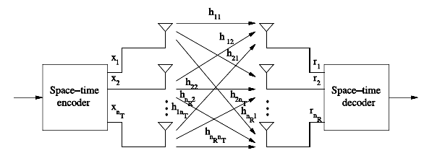
Fig. 1 Block Diagram of MIMO

Space-time trellis codes have a potential drawback that the maximum likelihood decoder complexity grows exponentially with the number of bits per symbol, thus limiting achievable data rates. Foschini proposed a layered space-time (LST) architecture that can attain a tight lower bound on the MIMO channel capacity. The distinguishing feature of this architecture is that it allows processing of multidimensional signals in the space domain by 1-D processing steps, where 1-D refers to one dimension in space. The method relies on powerful signal processing techniques at the receiver and conventional 1-D channel codes.

II. CHANNEL MODELLING
Mobile radio channels are extremely random and vary from simple light of sight to one that is severely obstructed by buildings, mountains and foliage. Apart from the locations of transmitter and receiver, the speed of motion impacts how rapidly the signal level fades as a mobile terminal moves in a space. Characterisation and modelling of the radio channel has been one of the most difficult parts of mobile radio system design. Basic propagation mechanism are as under:
- Reflection: When a propagating EM waves impinges upon an object which has very large dimensions compared to the wavelength of the propagating wave.
- Diffraction: When the radio path between transmitter and receiver is obstructed by a surface that has sharp edges. So bending of waves takes place.
- Scattering: Scattered waves are produced by rough surfaces, small objects or by other irregularities in the channel.
II(a) Rayleigh fading channel
A very common MIMO fading model is the i.i.d. Rayleigh fading model:
the entries of the channel gain matrix H[m] are independent, identically distributed and circular symmetric complex Gaussian. Since the matrix Hm and its angular domain representation Hª[m] are related by
Hª[m]= ………(2.1)
and Ur and Ut are fixed unitary matrices, this means that Hª should have the same i.i.d. Gaussian distribution as H. Thus, using the modelling approach described here, we can see clearly the physical basis of the i.i.d Rayleigh fading model, in terms of both the multipath environment and the antenna arrays. There should be a significant number of multipath in each of the resolvable angular bins, and the energy should be equally spread out across these bins. This is the so called richly scattered environment. If there are very few or no paths in some of the angular directions, then the entries in H will be correlated. Moreover, the antennas should be either critically or sparsely spaced. If the antennas are densely spaced, then some entries of Hª are approximately zero and the entries in H itself are highly correlated. However, by a simple transformation, the channel can be reduced to an equivalent channel with fewer antenna switch are critically spaced.
Compared to the critically spaced case, having sparser spacing makes it easier for the channel matrix to satisfy the i.i.d. Rayleigh assumption. This is because each bin now spans more distinct angular windows and thus contains more paths, from multiple transmit and receive directions. This substantiates the intuition that putting the antennas further apart makes the entries of H less dependent. On the other, if the physical environment already provides scattering in all directions, then having critical spacing of the antennas is enough to satisfy the i.i.d. Rayleigh assumption. Due to the analytical tractability, we will use the i.i.d. Rayleigh fading model quite often to evaluate performance of MIMO communication schemes, but it is important to keep in mind the assumptions on both the physical environment and the antenna arrays for the model to be valid.

III. Mathematical modelling of VBLAST Architecture
Without knowledge of the channel at the transmitter the choice of the coordinate system in which the independent data streams are multiplexed has to be fixed a priori. In conjunction with joint decoding, we will see that this transmitter architecture achieves the capacity of the fast fading channel. This architecture is also
called V-BLAST in the literature.
The input information sequence, denoted by x, is first demultiplexed into n_{T} sub-streams and each of them is subsequently modulated by an M-level modulation scheme and transmitted from a transmit antenna. The signal processing chain related to an individual sub-stream is referred to as a layer. The modulated symbols are arranged into a transmission matrix, denoted by H, which consists of n_{T} rows and L columns, where L is the transmission block length. The tth column of the transmission matrix, denoted by x_{t} , consists of the modulated symbols , where t = 1, 2, . . . ,L. At a given time t , the transmitter sends the tth column from the transmission matrix, one symbol from each antenna. That is, a transmission matrix entry is transmitted from antenna i at time t . Vertical structuring refers to transmitting a sequence of matrix columns in the space-time domain. This simple transmission process can be combined with conventional block or convolutional one-dimensional codes, to improve the performance of the system. This term “one-dimensional” refers to the space domain, while these codes can be multidimensional in the time domain.
Consider a 2×2 MIMO systems where the received signal can be represented as
y=Hx+n ……………..(3.1)

where x= [x₁ x₂]^{T} denotes two independent symbols, n= [n₁ n₂]^{T} is AWGN and n_{i}~CN (0,N₀) for i= 1, 2. Here, spatially uncorrelated channel matrix H= [h₁ h₂] or
H= 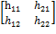 , ……………(3.2)
Where h_{ij} ~ CN (0,1) denotes channel between i^{th} transmit and j^{th} receive antenna.
Now, H⁻¹ can be represented as
H⁻¹=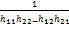 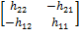 ………..(3.3)

Geometrically, we can interpret h_{i} as the direction of the signal from the transmit antenna i. to decouple the detection of the two symbols, one idea is to invert the effect of channel.
ỹ=H⁻¹y
= x+H⁻¹n
= + 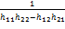 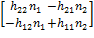
………………….(3.4)
Let us focus on the detection of symbol . Then, is with zero mean and variance of
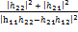N₀ ………………..(3.5)
Hence, the detection variable for x₁ can be represented as
ỹ₁=x₁+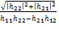z …………….…....(3.6)
where z₁ ~ CN(0,N₀).

III(a) The Decision Rule
These signals are then sent to the zero forcing detector which, for each of the signals x₁ and x₂ use the decision rule expressed below.
Choose iff
The detection variable
ỹ₁=x₁+z ……………………(3.7)

ỹ_{1 ≥} 0, the detected symbol is 1.
ỹ_{1 ≤} 0, the detected symbol is 0.

Choose iff
The detection variable
ỹ₂=x₂+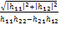z ……………(3.8)

ỹ_{2 ≥} 0, the detected symbol is 1.
ỹ_{2 ≤} 0, the detected symbol is 0.

IV. Encoding and Decoding Algorithm
IV(a) Introduction
This section illustrates the performance of VBLAST through simulation .MatLab is been used as a tool to carry out the simulation. Following simulation set-up has been developed in MatLab environment.
IV(b) Simulation set up
The simulation set up is composed of four distinct parts, namely the bit generator, the LST-encoder, the channel and the ML decoder.
IV(c) Information Bit Generator
Information Bit Generator the sequence of bits composed of 0 and 1 using uniformly distributed random number. The mean value and variance value of input bits are 0.5 and 0.25 respectively.

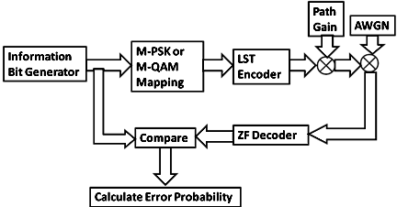

Fig. 2 Block diagram of simulation

IV(d) M-PSK Mapping
M-PSK MappingBPSK,4-PSK,8-PSK modulation have been used .The bit sequence is divided into symbols which are composed of several bits e.g., 2 bits represent one symbol for Q-PSK ,and then each symbol is been mapped to the constellation point using Gray-coded ordering .The gray coded symbol is changed to the complex output form.
IV(e) Layered Space Time Coding
Layered Space Time Coding generates encoder matrix (2x2) and transmit to the channel.Generation matrix.
IV(f) Channel
Channel is considered as Rayleigh flat fading channel. The dominant factor is the path gain form each transmit antenna to each receive antenna. The path gain is the independent complex Gaussian random variables with variance 0.7 per real and imaginary parts. Additionally, the usual additive white Gaussian noise corrupts the signal. The AWGN and the Rayleigh fading channel are generated using.
nj = randn (1,N) + J * randn (1,N)
hj = 0.7 * (( randn (1,N) + J * randn (1,N)) ...(4.1)
IV(g) Zero forcing (ZF) decoding
ZF decoding algorithm is been used to decode the received complex signal. Decoding algorithm and equations are given in section III.
IV(h) Bit Error Rate
Bit Error Rate of the system is been computed as the ratio of incorrect data bits divided by the total number of data bits transmitted and the probability of bit error rate can be calculated as following equation:
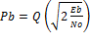 ……………(4.2)

V. Analysis of simulation results & conclusion
We plot the graphs of simulation to analyze the performances of various system are plotted below.
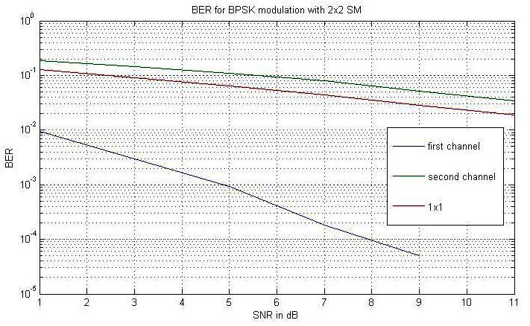
Fig. 3 BER vs SNR of BPSK with Nt=Nr=2
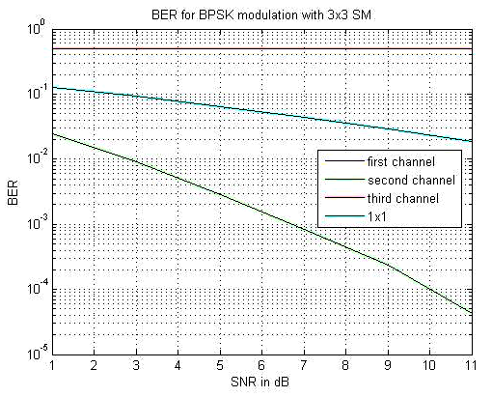
Fig. 4 BER vs SNR of BPSK with Nt=Nr=3
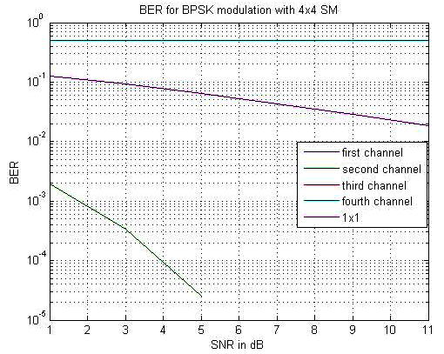
Fig. 5 BER vs SNR of BPSK with Nt=Nr=4

Figures 3,4, and 5 shows that the BER decreases as we goes to increse the no. of transmit and receive antennas.
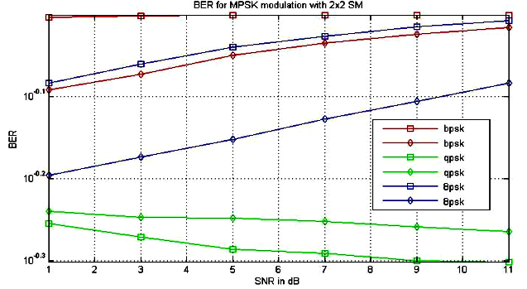
Fig. 6 BER vs SNR of BPSK, QPSK, 8PSK with Nt=Nr=2

V(a) Conclusion
We have studied the performance of spatial multiplexing VBLAST of 2x2 system with MPSK modulation in i.i.d Rayleigh fading channel and 2x2, 3x3 & 4x4 with BPSK modulation in Rayleigh fading channel. So by studying the above graphs we seen that the BER performance is increased and improved in QPSK modulation then other methods.

VI. References
[1] S. Alamouti, “ A simple transmit diversity technique for wireless communications, ” IEEE Journal on selected areas in communications, vol. 16, no. 8, pp. 1451–1458, 1998.
[2] Andreas Constantinides Assaf Shacham “MIMO Wireless Systems” May 14, 2004
[3] Jaime Adeane, Miguel R.D. Rodrigues, Inaki Berenguer, and Ian J. Wassell “Improved Detection Methods for MIMO-OFDM-CDM Communication Systems”Laboratory for Communication Engineering Department of Engineering University of Cambridge 15 JJ Thomson Avenue, Cambridge CB3 0FD, United Kingdom fja316, mrdr3, ib226, ijw24g@cam.ac.uk
[4] N.B. SINHA, Ast. Prof.Department of ECE and EIE, C.E.M.K, K.T.P.P. Township, W.B, India-721171. R. BERA, Prof., Department of E.C.E, SMIT, Sikkim, Majitar India - 737132.M. MITRA, Assistant Prof., Department of E.T.E,BESU, Howrah, W.B, India.“CAPACITY AND V-BLAST TECHNIQUES FOR MIMO WIRELESS CHANNEL ”
[5] David Gesbert, Member, IEEE, Mansoor Shafi, Fellow, IEEE, Da-shan Shiu, Member, IEEE, Peter J. Smith, Member, IEEE, and Ayman Naguib, Senior Member, IEEE “From Theory to Practice: An Overview of MIMO Space–Time Coded Wireless Systems”
[6] Hiroshi Nishimoto, Student Member, IEEE, Yasutaka Ogawa, Senior Member, IEEE, Toshihiko Nishimura, Member, IEEE, and Takeo Ohgane, Member, IEEE “Measurement-Based Performance Evaluation of MIMO Spatial Multiplexing in a Multipath-Rich Indoor Environment”
[7] G. J. Foschini, “Layered space-time architecture for wireless communication”, Bell Labs. Technology. Journal, Vol. 6, No.3, PP. 311-335(1998).
[8] M. Jankiraman, “Space time Codes and MIMO Systems”, published by Artech House, 2004.
[9] T. L. Marzetta, “BLAST training: Estimating channel characteristics for high capacity space-time wireless,” in Proc. 37th Annual Allerton Conf. Communication, Control and Computing, Monticello, IL, 1999.
[10] “On the Practical Performance of VBLAST”
See Ho Ting, Student Member, IEEE, Kei Sakaguchi, Member, IEEE, and Kiyomichi Araki, Member, IEEE
[11] Heung-Gyoon Ryu, Sang Burm Ryu, Seon-Ae Kim, “ Design and Performance Evaluation of the MIMO SFBC CI-OFDM Communication System,”The Fourth International Conference on Wireless and Mobile Communications DOI 10.1109/ICWMC.2008.10
[12] Fang-Biau Ueng, Shang-Chun Tsai and Jun-Da Chen, “ Adaptive Detectors for MIMO DS/CDMA Communication Systems, ”IEEE Transactions On Vehicular Technology, Vol. 57, No. 5, September 2008
[13] Dominik Seethaler, Harold Artes, and Franz Hlawatsch “Detection Techniques for MIMO Spatial Multiplexing Systems ”Elektrotechnik und Informationstechnik (e&i), vol. 122, no. 3, March 2005, pp. 91–96.Copyright 2005 Springer-Verlag
[14] Fang Wang, “ The Application of MIMO-OFDM System in troposcatter communication, ” 978-1-4244-1880 ©2008 IEEE.
[15] “Space-Time Coding” by Branka Vucetic, University of Sydney, Australia
Jinhong Yuan, University of New South Wales, Australia. Copyright 2003 John Wiley & Sons Ltd
[16] “Space-Time Coding for Broadband Wireless Communications” by GEORGIOS B. GIANNAKIS, ZHIQIANG LIU, XIAOLI MA
SHENGLI ZHOU, Copyright © 2007 by John Wiley & Sons, Inc.
[17] “Space-Time Coding” by Branka Vucetic
University of Sydney, Australia
Jinhong Yuan University of New South Wales, Australia, Copyright © 2003 John Wiley & Sons Ltd.

